**Questions to ask:**

1.Where does the flight from PHX go?

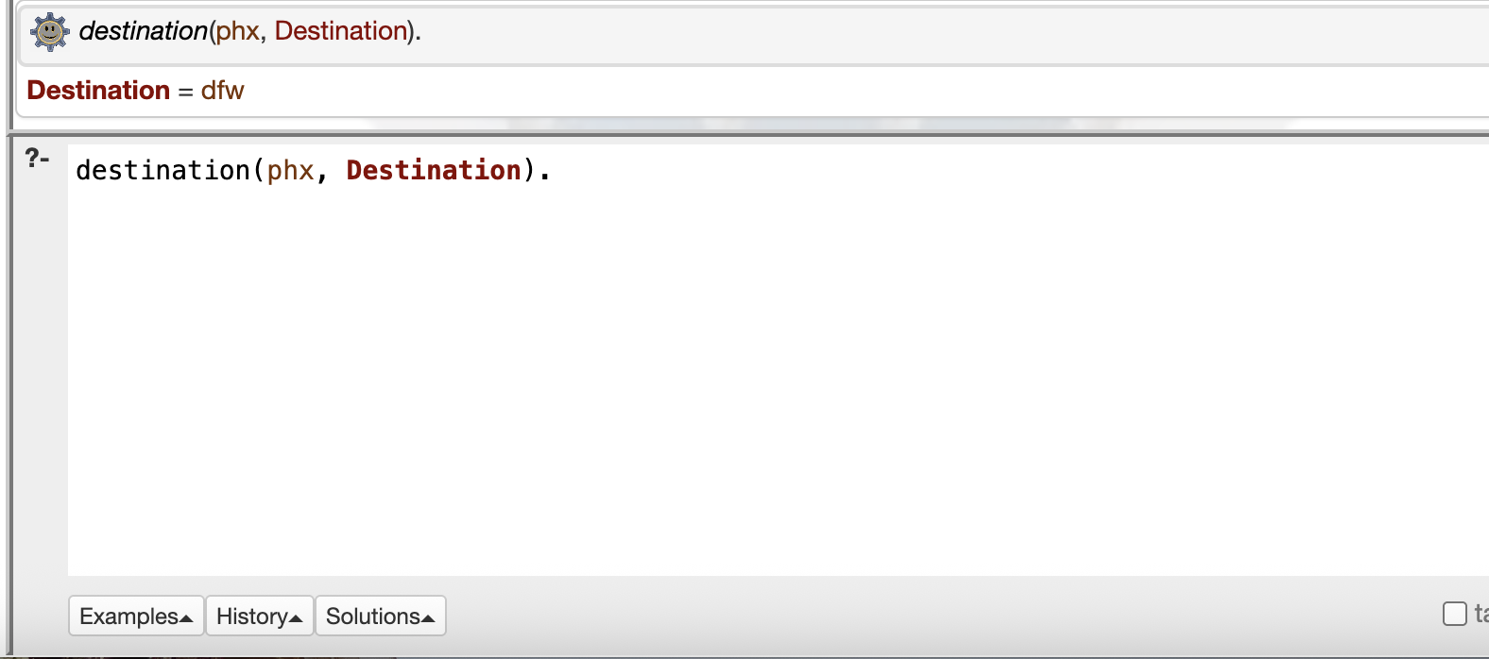

1. Is there a flight to PHX?

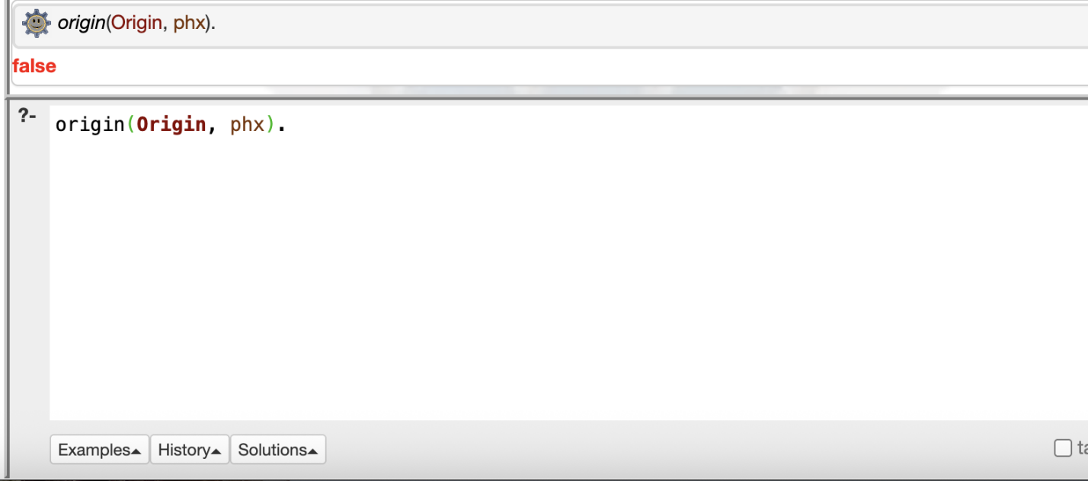

3.What time is does the flight from BOS land?

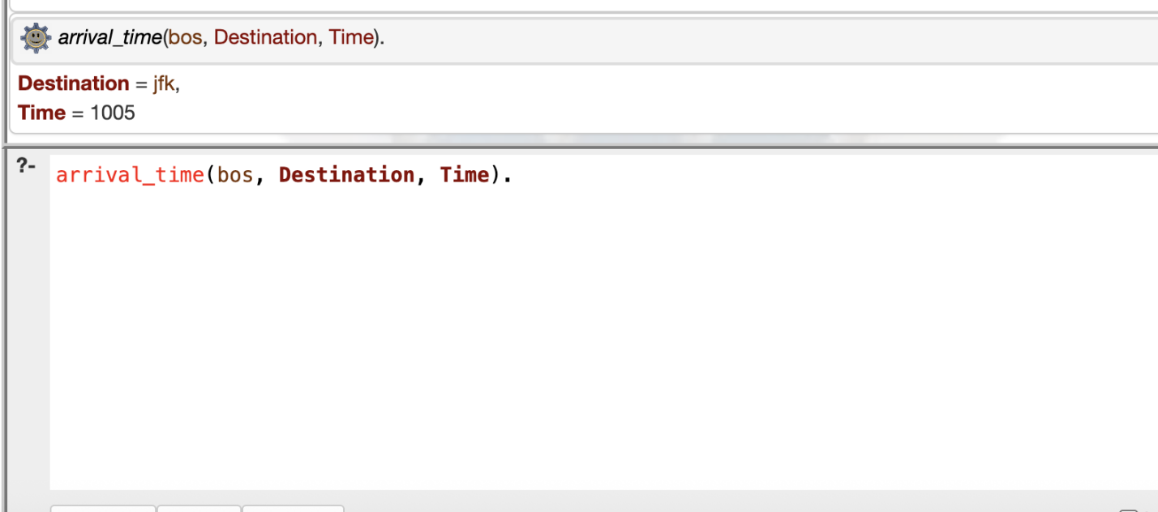

4.Does the flight from ORD to SFO depart after the flight from EWR to ORD lands?

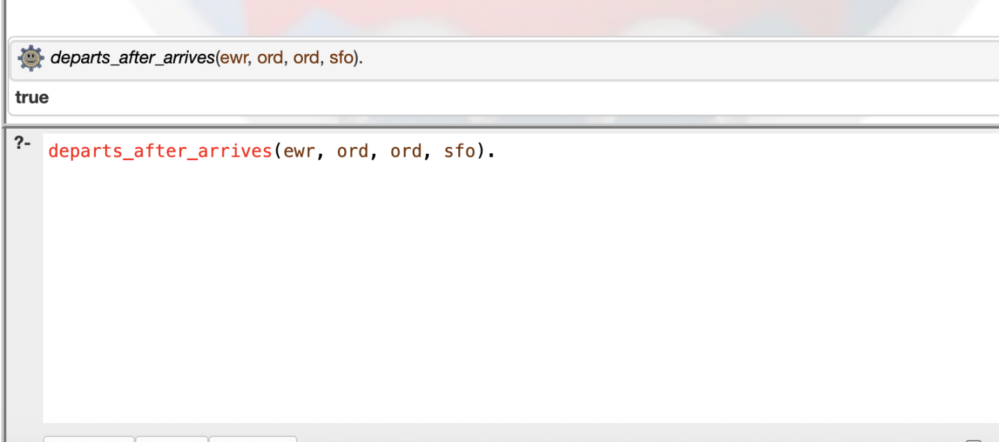

5.What time do the flights to ORD arrive?

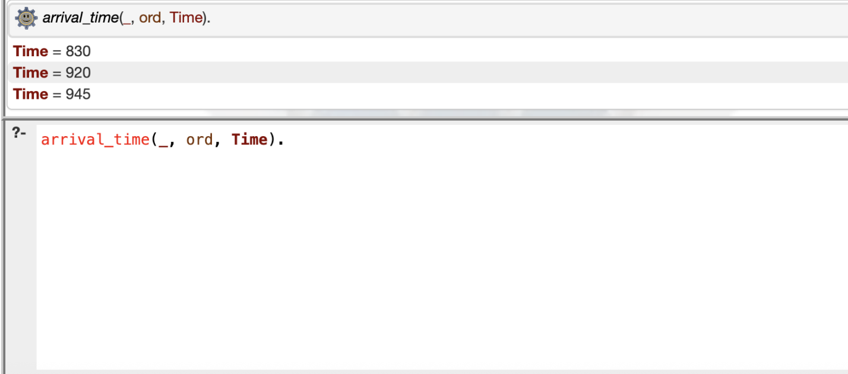

1. What are all the ways to get from LGA to LAX?

